Suri Vidyasagar College (Govt. Sponsored)
Suri, Birbhum, 731101

Date:11.07.2021
Notice

College will remain closed on 12.07.2021 (Monday) on account of Holiday “Ratha Yatra”. However emergency services and form fill up for Examination, 2021 will run as usual.

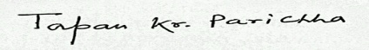
Principal
Suri Vidyasagar College

